NiMAP toolkit for companies

Exercise leaflets



The exercise leaflets in this document are designed by Vlerick Business School and Talentree with the support of the European Social Fund and the Flemish Government to help organisations in creating a diverse and inclusive work environment. They are part of the training toolkit for companies, which is based on learnings we gathered during a project focused on guiding highly-educated newcomers and companies to fasten the job search and induction process on the work floor. The training toolkit consists of 4 modules, designed for companies looking to diversify their talent pool:

* module 1: Multicultural Diversity on The Agenda
* **module 2: Building a Diverse organisation: Getting The Foundations Right**
* module 3: Recruiting for Diversity
* module 4: Managing Diversity in The Workplace

The modules are designed in such a way companies can use them autonomously to set up their own diversity initiatives and workshops. Each module consists of:

* 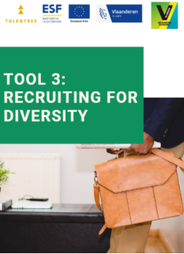a tool
* an interactive PowerPoint presentation
* detailed leaflets of each exercise referred to in the PowerPoint presentation by a blue dotted background

This document combines all exercise leaflets for module 2.

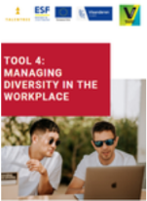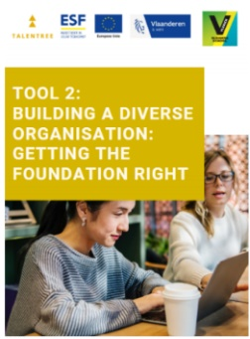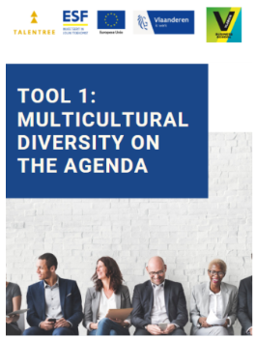

**TABLE OF CONTENTS**

**MODULE 2:****Building a diverse organisation: getting the foundations right 1**

2.1. DEFINING STAKEHOLDERS 2

2.2. STAKEHOLDER GRID 4

2.3. FROM MONO TO INTERCULTURAL MINDSET 15

2.4. RIDDLES 18

2.5. TRUST BUBBLE 22

2.6. TESTIMONIAL ACCENTURE 25

**CONTACT US 29**

MODULE 2

Building a diverse organisation: getting the foundations right

* 1. DEFINING STAKEHOLDERS

PRACTICAL GUIDELINES

|  |  |
| --- | --- |
| Objectives | * Reflecting on why companies should invest in diversity |
| Target group | A team that wants to invest more in diversity and needs to get the whole company on board. |
| Number of participants | Ideally 8 – 30 people  Exercise can be done with the entire group  It’s also possible to divide the group into subgroups of +/- 4 people and conduct the discussion with the entire group |
| Duration | 15 minutes |
| Set-up | Material:   * Flipchart |

INSTRUCTIONS

|  |
| --- |
| Who are the most important stakeholders to get on board when introducing a new diversity initiative? Think about who you need by your side to make things work. |

DISCUSSION

|  |
| --- |
| Write down all the stakeholders the participants mention (use a flipchart). |
| Questions to ask with regard to each stakeholder:   * Why it’s important to convince this stakeholder? * What could be sources of resistance? |

* 1. STAKEHOLDER GRID

PRACTICAL GUIDELINES

|  |  |
| --- | --- |
| Objectives | * Linking diversity to positive organisational outcomes * Thinking about how different stakeholders can be convinced to invest in diversity * Prioritizing which stakeholders need to be convinced first |
| Target group | * A team that wants to convince one or more stakeholders to invest in diversity |
| Number of participants | Divide the group into subgroups of +/- 4 people and conduct the discussion with the entire group |
| Duration | 20 minutes |
| Set-up | Material:   * Stakeholder grid (cfr. Attachment I) * Pens |
| Comment | This exercise builds upon leaflet 1.3. and leaflet 2.1., it’s possible to introduce the stakeholder grid already during the previous exercises (doing so, participants can include their output of these exercises into the grid and add output of leaflet 2.2. later on) |

INSTRUCTIONS

|  |
| --- |
| Let’s use the following exercise to focus on the value of diversity for the different stakeholders. |
| You have 10 minutes to discuss with each other how the different stakeholders can be convinced. Focus on how an investment in diversity leads to positive organisational outcomes. |
| Divide the group into subgroups of +/- 4 people. |
| Each group chooses 2 stakeholders they want to convince in their company. Think about which of the listed arguments (benefits of investing in diversity and risks of not investing in diversity) might be useful to convince your stakeholder of choice to make them get on board of your diversity programme. Translate the arguments in concrete actions. Write down your answers in the grid. |
| First do this individually (on individual grids). Then share your ideas and write down the group answers in a shared grid. |
| Once you completed the grid, select the 3 highest priorities. |

ROLE PLAYS

|  |
| --- |
| Each group now actually has to convince a stakeholder group. Therefore, appoint another subgroup to take on the role of the stakeholder of choice. The stakeholders have to be critical towards their persuaders (don’t take all the arguments for granted, ask critical questions!). |
| Make sure each group once takes on the role of persuader and once takes on the role of stakeholder. |

DISCUSSION

|  |
| --- |
| Ask participants for their experiences:   * How did it feel to persuade? * How did it feel to represent the stakeholder group? |

ATTACHMENT I

|  |  |  |  |  |  |  |  |
| --- | --- | --- | --- | --- | --- | --- | --- |
|  | | Board/C-level | Line Management | HR Recruitment | Corporate Citizenship | Employees | Unions |
| Benefits of investing diversity | Winning the war for talent |  |  |  |  |  |  |
| Strengthening customer orientation |  |  |  |  |  |  |
| Improving decision making and innovation |  |  |  |  |  |  |
| Increasing employee satisfaction |  |  |  |  |  |  |
| Enhancing the company’s image/CSR |  |  |  |  |  |  |
| Risks when not investing in diversity | Limited access to talent |  |  |  |  |  |  |
| Irrelevance |  |  |  |  |  |  |
| Turnover |  |  |  |  |  |  |
| Negative brand |  |  |  |  |  |  |
| Negative reactions |  |  |  |  |  |  |
|  |  |  |  |  |  |  |  |



* 1. FROM MONO TO INTERCULTURAL MINDSET

PRACTICAL GUIDELINES

|  |  |
| --- | --- |
| Objectives | * Discovering in which phase of inclusion your organisation can be situated * Reflect one what your organisation can do to become more inclusive |
| Target group | A team that wants to reflect on the inclusivity level of their organisation |
| Number of participants | Individual exercise  Discussion should be conducted with the entire group |
| Duration | 15 minutes |
| Set-up | Material:   * Questionnaire (cfr. Attachment I) * Pens |

INSTRUCTIONS

|  |
| --- |
| Hand out the questionnaire and ask the participants to fill it in. |

SCORING

|  |
| --- |
| Once everyone is finished, explain how to determine the phase of inclusion: “Count the score for each colour separately. When you have the highest score for the purple area, then your organisation is probably in the resistance phase. When you have the highest score for the orange area, you are probably in the conformity phase. The blue area reflects the inclusion phase, whereas the green area reflects the proactivity phase.” |

DISCUSSION

|  |
| --- |
| Give a short explanation of the different phases: “Dass and Parker distinguished four phases of willingness within organisations: conformity, inclusion, proactivity and resistance, although when your organisation is situated in the resistance phase, your organisation is showing no willingness at all. Organisations in a resistance phase might react in a bad way to imposed diversity initiatives because they do not see the advantage of it. That is why it is so important to create first awareness in such organisations before taking action. Most Western organisations can be situated in the conformity phase: they follow societal developments without doing more than what is legally obliged. Organisations that chase a workforce that represents the ecological framework and that truly believe in the benefits of diversity, can be situated in the inclusion phase. Organisations in the proactive phase go even beyond this: they intervene in the organisational structure in order to accommodate diversity the best as possible. Such organisations believe that a diverse workforce is crucial for long-term growth.” |
| Discuss with each other whether or not you agree with your score and what you could do to become more inclusive. |

ATTACHMENT I

|  |  |  |  |  |  |
| --- | --- | --- | --- | --- | --- |
|  | 1  Strongly disagree | 2  Disagree | 3  Neutral | 4  Agree | 5  Strongly agree |
| Diverse managers are seen as a threat |  |  |  |  |  |
| Our organisation undertakes nothing to attract diversity |  |  |  |  |  |
| Our organisation is following the legal minimum |  |  |  |  |  |
| Diversity is primarily concerned as barrier |  |  |  |  |  |
| We are an example for other companies concerning our diversity policy |  |  |  |  |  |
| We are actively searching for ways to attract diversity |  |  |  |  |  |
| The management uses diversity as their trump card |  |  |  |  |  |
| The structure of the organisation is adapted to the needs of the different cultures |  |  |  |  |  |

*Questionnaire adapted from Dass & Parker (1999)*

* 1. RIDDLES

PRACTICAL GUIDELINES

|  |  |
| --- | --- |
| Objectives | * Experience biases * Raise awareness on unconscious bias |
| Target group | A team that wants to reflect on diversity and unconscious biases towards people of foreign origin |
| Number of participants | Ideally 8 – 30 people  Exercise can be done with the entire group  It’s also possible to divide the group into subgroups of +/- 4 people and conduct the discussion with the entire group |
| Duration | 10 minutes |
| Set-up | Material:   * Riddles (cfr. Attachment I) * PowerPoint slides of the exercises can be found in the PowerPoint presentation of module 2 |

INSTRUCTIONS

|  |
| --- |
| Fill in the exercises. |

DISCUSSION

|  |
| --- |
| Present the solution of the exercise, using the PowerPoint slides 28-33 of the PowerPoint presentation of module 2. Solutions can be consulted in the notes of the slides. |
| Ask participants/subgroups:   * How they experienced the riddles? * How they can explain wrong answers? * How do biases influence our daily behaviour? * … |

ATTACHMENT I

**Riddle 1**

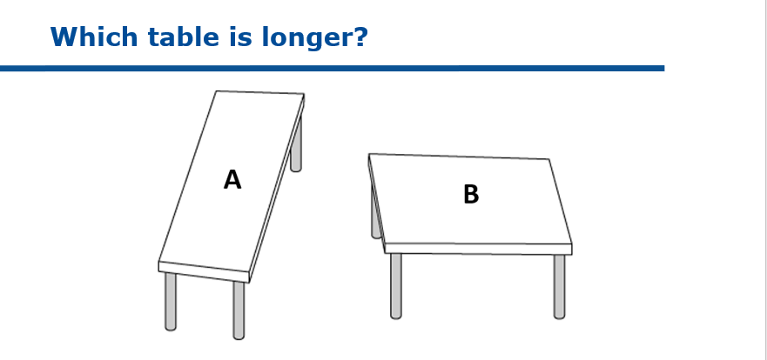

Answer: _________________________________________________________

**Riddle 2**

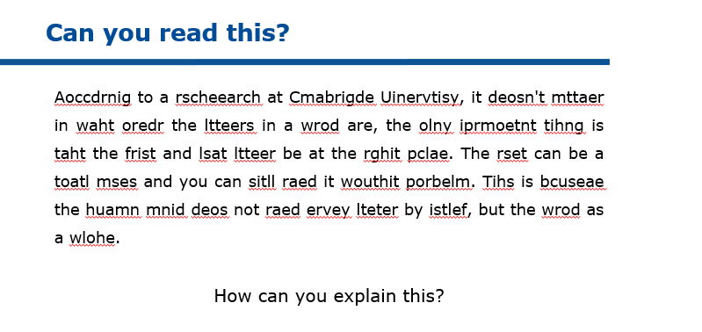

Answer: _________________________________________________________

**Riddle 3**

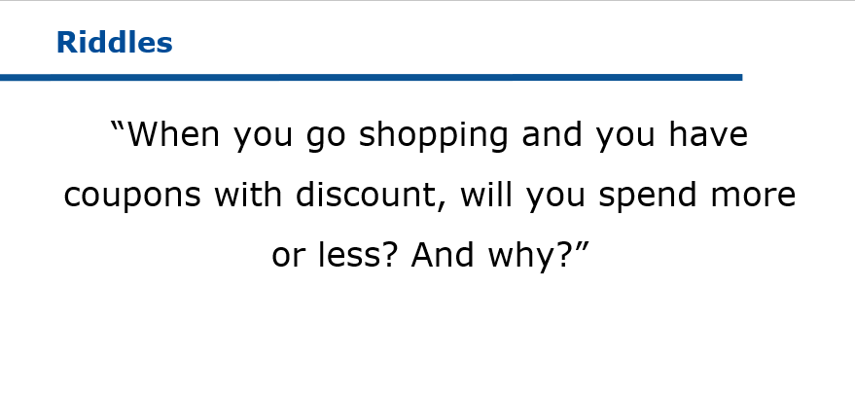

Answer: _________________________________________________________

**Riddle 4**

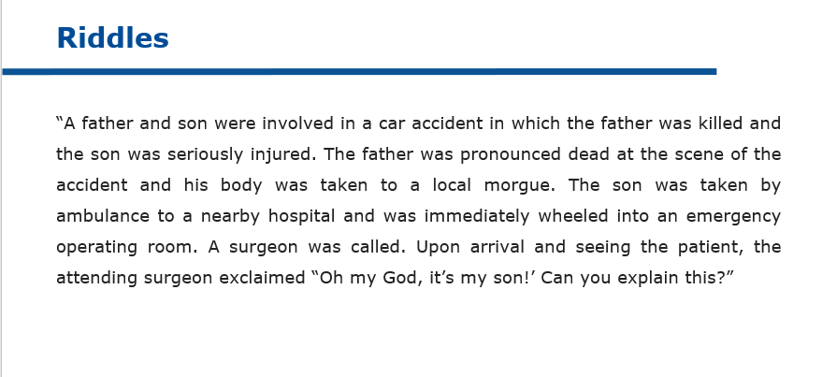

Answer: _________________________________________________________

* 1. TRUST BUBBLE

PRACTICAL GUIDELINES

|  |  |
| --- | --- |
| Objectives | * Raising awareness on similarity attraction and affinity bias |
| Target group | A team that wants to reflect on diversity and unconscious biases towards people of foreign origin |
| Number of participants | Individual exercise  Discussion should be conducted with the entire group |
| Duration | 15 minutes |
| Set-up | Material:   * Form (cfr. Attachment I) * Pens |

INSTRUCTIONS

|  |
| --- |
| Fold the form in 2 in such a way participants can only see the first column: FIRST NAME. |
| Hand out the folded forms. |
| Ask participants to write down at least 5 people they trust blindly (who are NOT family members). |
| Then make everyone unfold the form so they see the other columns. |
| Ask everyone to fill in the other columns: what’s the gender, ethnicity, colour skin, age, profession, sexual orientation and educational background of the people they trust the most? |

DISCUSSION

|  |
| --- |
| Below there are some guiding questions to start a discussion:   * Do you notice any tendencies? * Who has at least 1 person on his/her list with a colour skin different from their own? * Who has at least 1 person on his/her list with an ethnicity different from their own? * … |
| How come the people we trust the most are so similar (to us)? |

ATTACHMENT I

**The Trust Bubble**

|  |  |  |  |  |  |  |  |
| --- | --- | --- | --- | --- | --- | --- | --- |
| FIRST NAME | GENDER | ETHNICITY | COLOUR SKIN | AGE | PROFESSION | SEXUAL ORIENTATION | EDUCATIONAL BACKGROUND |
| 1. |  |  |  |  |  |  |  |
| 2. |  |  |  |  |  |  |  |
| 3. |  |  |  |  |  |  |  |
| 4. |  |  |  |  |  |  |  |
| 5. |  |  |  |  |  |  |  |



* 1. TESTIMONIAL ACCENTURE

PRACTICAL GUIDELINES

|  |  |
| --- | --- |
| Objectives | * Gaining insight in real business initiatives to get started with diversity initiatives |
| Target group | A team that wants to invest more in diversity and wants to get inspired by best practices of other companies |
| Number of participants | Divide the group into subgroups of +/- 4 people and conduct the discussion with the entire group |
| Duration | 15 minutes |
| Set-up | Material:   * Testimonial (cfr. Attachment I) |

INSTRUCTIONS

|  |
| --- |
| When starting with diversity initiatives, companies can learn valuable lessons from each other. For this reason it’s important that companies share experiences, ideas, potential pitfalls,… with one another. |
| Read the case of Accenture and try to distil best practices, opportunities to implement similar initiatives in your organisation, potential pitfalls,… Focus on what you can learn from Accenture’s story. |

DISCUSSION

|  |
| --- |
| Ask the group to share their takeaways. |
| Important learning lessons are:   * Ensure sponsorship of the executives * Assign a changemaker/project owner * Establish a joint vision why you do this * Develop KPI’s * Build ambassadorship * Build a network of sourcing partners * Develop a business case |

ATTACHMENT I

**Testimonial Accenture**

**Diversity drives engagement and business results**

Three years ago, we decided to challenge ourselves on how Accenture as employer could open up to more diverse talent groups like refugees and migrants. To do this, we wanted to further build on our Corporate Citizenship program ‘Skills to Succeed’ through which Accenture is already equipping minority groups with the right skills to find a job or build a business. This program not only aligns with Accenture’s inclusive company values, but also positively impacts our employee engagement and retention and brings new and different perspectives resulting in better business solutions and results.

**Sponsorship and clear** Key Performance Indicator **(KPI)**

A key driver of our new diversity initiative was the sponsorship of our Country Managing Director, Bart De Ridder. He has a clear motivation: To be a successful as innovation-driven company, you need a diverse workforce with people from different backgrounds bringing in different perspectives. From the outset we defined a very specific KPI with the HR team: 5% of all new hires should be sourced through our Skills to Succeed program. This KPI is set on a country level and not per team because we believe it’s better to inspire people to act as role models than to point the finger and force certain actions. In other words: we’re convinced that a bottom-up, organic approach is more effective than a top-down directive.  Within the HR team, we have a single point of contact (SPOC) who advises the recruitment team, ambassadors (managers who support the initiative and lead selection interviews) and candidates. If necessary, this individual is ready to give them a gentle push to leap into the unknown.

**First success stories**

To date, we have hired seven untapped international talents with a permanent contract and welcomed another twelve newcomers with paid internships. This experience has already taught us that post-hiring follow-up requires just as much attention as the (pre-)hiring phase. As a result, we now assign a mentor to every person hired via the Skills to Succeed program, not only to support their work-related needs but also as a sounding board for private challenges impacting professional life (e.g. administration, childcare…). In terms of developing their technical and language skills, these new hires use the Accenture online learning platforms, available for all our employees and customized to the needs of each employee.

**Stronger together**

Today, we share Accenture’s good practices with other companies via [Talent2Connect](http://www.talent2connect.be/), a collective platform for impactful employment solutions. The platform builds a bridge between companies looking for talent and the different social organizations in Belgium working with jobseekers who encounter barriers on the traditional labor market. Talent2Connect facilitates this matchmaking so that companies and untapped talent meet each other in a refreshing and impactful way.

*Magali Frankl, Corporate Citizen Lead, Accenture Belgium & Luxembourg*

Contact us

,;

