NiMAP toolkit for companies

Exercise leaflets



The exercise leaflets in this document are designed by Vlerick Business School and Talentree with the support of the European Social Fund and the Flemish Government to help organisations in creating a diverse and inclusive work environment. They are part of the training toolkit for companies, which is based on learnings we gathered during a project focused on guiding highly-educated newcomers and companies to fasten the job search and induction process on the work floor. The training toolkit consists of 4 modules, designed for companies looking to diversify their talent pool:

* module 1: Multicultural Diversity on The Agenda
* module 2: Building a Diverse organisation: Getting The Foundations Right
* **module 3: Recruiting for Diversity**
* module 4: Managing Diversity in The Workplace

The modules are designed in such a way companies can use them autonomously to set up their own diversity initiatives and workshops. Each module consists of:

* 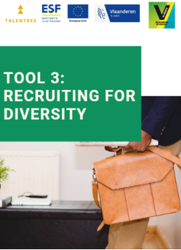a tool
* an interactive PowerPoint presentation
* detailed leaflets of each exercise referred to in the PowerPoint presentation by a blue dotted background

This document combines all exercise leaflets for module 3.

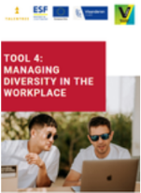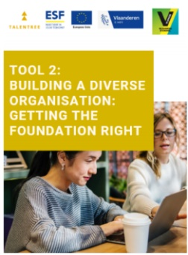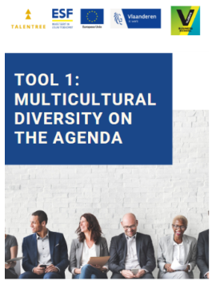

**TABLE OF CONTENTS**

**MODULE 3:****Recruiting for diversity 1**

3.1. TACKLE BIAS BEFORE IT TACKLES YOU 2

3.2. CV SCREENING 4

3.3. PERSONAL GOALS 7

3.4. TESTIMONIAL CITY OF GHENT & PUBLIC CENTER FOR SOCIAL WELFARE GHENT 10

**CONTACT US 14**

MODULE 3

Recruiting for diversity

* 1. TACKLE BIAS BEFORE IT TACKLES YOU

PRACTICAL GUIDELINES

|  |  |
| --- | --- |
| Objectives | * Reflecting on how one could prevent bias in recruitment processes |
| Target group | A team that wants to reduce unconscious bias in recruitment processes |
| Number of participants | Ideally 8 – 30 people  Exercise can be done with the entire group  It’s also possible to divide the group into subgroups of +/- 4 people and conduct the discussion with the entire group |
| Duration | 10 minutes |
| Set-up | Material:   * Flipchart |

INSTRUCTIONS

|  |
| --- |
| Which actions could you take to prevent bias sneaking into your recruitment processes? |

DISCUSSION

|  |
| --- |
| List all the actions (use a flipchart). |
| Once all the ideas are on the flipchart: ask the participants which of them are long-term actions and which of them could be quick-wins? |
| What will you do different tomorrow (let each participant choose one quick-win)? |

* 1. CV SCREENING

PRACTICAL GUIDELINES

|  |  |
| --- | --- |
| Objectives | * Reflecting on which criteria one usually uses * Creating awareness on how biased these criteria are |
| Target group | A team that wants to reduce unconscious bias in recruitment processes |
| Number of participants | Divide the group into subgroups of +/- 4 people and conduct the discussion with the entire group |
| Duration | 15 minutes |
| Set-up | Material:   * A vacancy text that’s currently being advertised by the company * Template (cfr. Attachment I) |

INSTRUCTIONS

|  |
| --- |
| Which criteria do you use when screening CV’s? Answering this question is crucial to get more insight in how you act in your role as recruiter. |
| Recruiters usually follow a pattern when they screen a pile of CV’s: they screen for the same criteria in a fixed sequence of “must haves” and “no-go’s”. The best way to identify your personal “sequence” is to screen a CV in a very conscious way. |

EXERCISE

|  |
| --- |
| Read the vacancy text of a position that’s currently being advertised on the job page of your company. |
| List the criteria you think are very important for this specific position in the “must have” column. List the “nice to have” criteria in the second column and finally list no-go criteria in the “don’t have” column. |

DISCUSSION

|  |
| --- |
| Listen to the different criteria the participant wrote down. |
| Try to challenge criteria that might be biased (such as gaps in CVs, no birth date on CV, foreign education,…). To know whether a criterion is biased one must ask the question “how does this criterion predicts job performance for this specific job”? If the answer is not clear, the criterion is probably biased. |
| Typical don’t haves are: lay-out, overqualified, no native language, gap in CV, no birth dates, foreign education. All these listed criteria are biased as they do not predict actual job performance. Foreign-born people tend to be more prone to these don’t have criteria than natives. They thus have a systematic disadvantage when compared to natives. |

ATTACHMENT I

**CV Screening exercise**

|  |  |  |
| --- | --- | --- |
| MUST HAVES | NICE TO HAVES | DON’T HAVES |
|  |  |  |
|  |  |  |
|  |  |  |
|  |  |  |
|  |  |  |
|  |  |  |

* 1. PERSONAL GOALS

PRACTICAL GUIDELINES

|  |  |
| --- | --- |
| Objectives | * Incorporate small changes in current recruitment strategies to tackle bias * Translate theory to one’s individual work situation |
| Target group | A team that wants to reduce unconscious bias in recruitment processes |
| Number of participants | Individual exercise |
| Duration | 10 minutes |
| Set-up | Material:   * Card (cfr. Attachment I), preferably printed on hard paper or cardboard and cut out |

INSTRUCTIONS

|  |
| --- |
| Which actions could you take to prevent bias sneaking into your recruitment processes? |
| Write down your 3 personal goals for the coming time: what will you be doing differently tomorrow that will reduce bias? |
| Formulate your goals SMART: specific, measurable, attainable (realistic), relevant, timebound. |

DISCUSSION

|  |
| --- |
| You can fold the card in half and put your personal goals on your desk to remind you of them. Ask your colleagues to challenge you on a regular basis! |

ATTACHMENT I



* 1. TESTIMONIAL CITY OF GHENT & PUBLIC CENTER FOR SOCIAL WELFARE GHENT

PRACTICAL GUIDELINES

|  |  |
| --- | --- |
| Objectives | * Gaining insight in real business initiatives to get started with diversity initiatives |
| Target group | A team that wants to invest more in diversity and wants to get inspired by best practices of other companies |
| Number of participants | Divide the group into subgroups of +/- 4 people and conduct the discussion with the entire group |
| Duration | 15 minutes |
| Set-up | Material:   * Testimonial (cfr. Attachment I) |

INSTRUCTIONS

|  |
| --- |
| When starting with diversity initiatives, companies can learn valuable lessons from each other. For this reason it’s important that companies share experiences, ideas, potential pitfalls,… with one another. |
| Read the case of City of Ghent & Public Center for Social Welfare Ghent (OCMW Gent) and try to distil best practices, opportunities to implement similar initiatives in your organisation, potential pitfalls,… Focus on what you can learn from this case. |

DISCUSSION

|  |
| --- |
| Ask the group to share their takeaways. |

ATTACHMENT I

**Testimonial City of Ghent & Public Center for Social Welfare Ghent**

The diversity action plan of the City of Ghent and the Public Centre for Social Welfare Ghent (OCMW) was brought to life in 2017. The plan focuses on different minority groups: people with a work disability, people of foreign origin, people aged 50+,… Our ultimate goal is to achieve a workforce that reflects the diverse society of Ghent: our service centres can only provide high-quality service if all layers of society are represented in our work teams.

**Specific goals and actions**

With regard to people with a migration background, our objective for 2020 is an inflow of employees of foreign origin that counts for 30% of our total inflow.

Several initiatives allow us to take steps in the right direction. For example, in our selection procedure we focus on the candidate’s competencies and try to avoid giving too much weight to diplomas and other culture-dependent criteria. Furthermore, the language used in our vacancies must be clear, simple and neutral. In addition, we regularly subject our selection methods to a critical evaluation: we screen the adverse impact of our tools to minimise bias towards certain groups.

We also organise meetings with civil society organisations that operate in Ghent. By doing so, we gather a lot of information from our target groups’ perspective. We also work closely with these organisations to advertise our open vacancies directly to our target groups.

**Experiences so far**

As a result of the diversity plan, our organisation is more consciously thinking about diversity and is more aware of the importance of diverse teams. We are all

striving towards one common goal, which creates a sense of unity. Another success story is the introduction of annual vocational trainings: paid internships

we offer to vulnerable job seekers in collaboration with VDAB. This year we offered vocational internships to 8 people of foreign origin and 2 people with a work disability. Overall reactions of line managers, colleagues and trainees were very positive.

**Lessons learned**

It is still difficult to determine the minimum language requirements. As a government agency, we are bound by language legislation: as all formal communication is in Dutch, every person who starts working with us must have a decent level of Dutch. However, we do not want to set our expectations too high and, as a consequence, miss talented people.

**What advice do you have for other companies?**

Developing and implementing a sound diversity plan costs time and must be coordinated by one or several dedicated employees who are working on diversity projects full time. That’s the only way to encourage the entire organisation to participate in our diversity initiatives. In addition, we have benefited a lot from engaging directly with our target groups through the civil society organisations. Gaining primary information is crucial to roll out a sustainable and effective policy that builds on mutual trust between the various stakeholders involved.

*Naomi Mike, Organisational Psychologist, Department Selection, City of Ghent & Public Center for Social Welfare Ghent*

Contact us

,;

